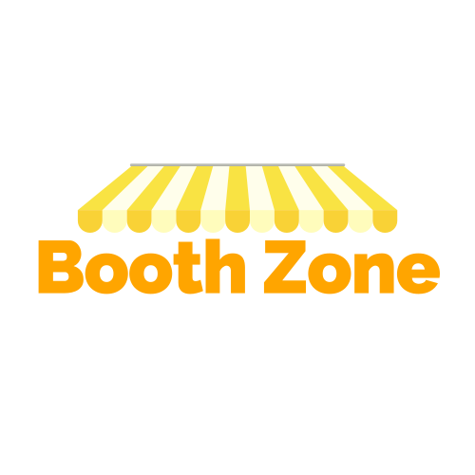

**Problem Statement -**

**Currently, all major events including business/Art exhibitions, Sports events, concerts among others generally deploy offline sales model to sell their booths which is a time consuming and cumbersome process for businesses buying booths in such events. Businesses need to invest considerable time to meet exhibition representatives to understand event attractiveness in terms of customer reach and business potential. Further, Businesses generally require multiple offline meetings to understand booth details such as location, dimensions, design and commercial negotiations which consumes a lot of time and requires close coordination. Also, event organizers need to employ many sales personnel to be able to successfully sell all available space in the event which is a major cost for them.**

**Problem Solution -**

**The most efficient way to reduce cost for event organizers, save time for booth buyers and make the entire process simple for both parties is to transition the entire business process to an online platform. our business proposition is to develop an efficient B2B portal which provides a one stop shop for businesses and will encompass end to end services like event marketing, Booth review selection and order placement, Booth designing and installation Services, Meeting scheduling services and associated manpower solutions. Further, our platform will also extend as a B2C Portal wherein exhibition visitors can purchase their entry passes. All in all, the scope of revenue generation and customer stickiness through our portal is huge as it addresses multiple pain points of businesses and customers organizing and participating in various events.**

**Proposed System**

* Booth Zone is a Platform which is focusing on both B2B and B2C customers.

**B2B-**

* In Booth Zone, a customer can Advertise the type of event he is organizing.
* The prices will pe derived according to the booth size.

**B2C-**

* Talking according to the B2C concept here customer can select the event/ exhibition which is been advertised by the organizer.
* The customer can book passes of the events like business summit,

Exhibitions etc. Which are been organized by the organizers.

* Customer will also be able to book a booth in that specific event of different sizes as provided by the organizer.

**Business Perspective**

Talking about the money making both B2B and B2C have their own ways to generate income.

**B2B-**

Here organizer will register his event and being a platform, we will be having our own charges criteria to list their exhibition , business summit etc.

**B2C-**

* Passes purchasing of different summit and giving more focus on customer stickiness. To generate more earnings.